- View all products:
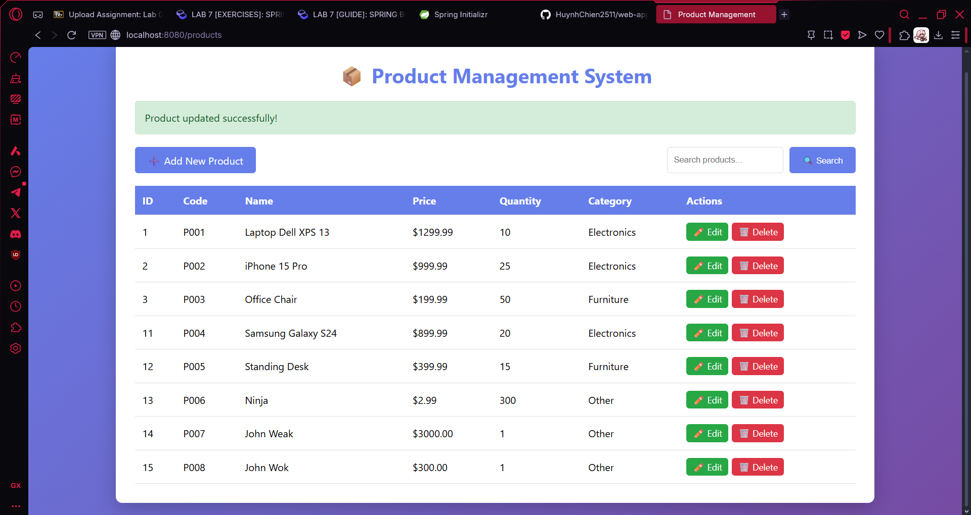
Access localhost:8080/products, browser send a GET request to server. Then the controller layer will call the service layer to get the data and at service layer it run productRepository.findAll() to get all product. At database, it will execute SQL for data and put it in a list to deliver to view layer which will visual all the list for user.

- Add new product:
At the list, click on add new product button, browser send a GET request to controller layer. The controller layer call showNewForm function, this function create a new object and call product-form.html to show the empty form. After filling the form and click save product, the browser send a POST request to controller and controller will saveProduct by calling service layer. This action will call INSERT query in SQL to save new information to database. After finish, the browser will send another GET request to /products to show the new list and a success message.
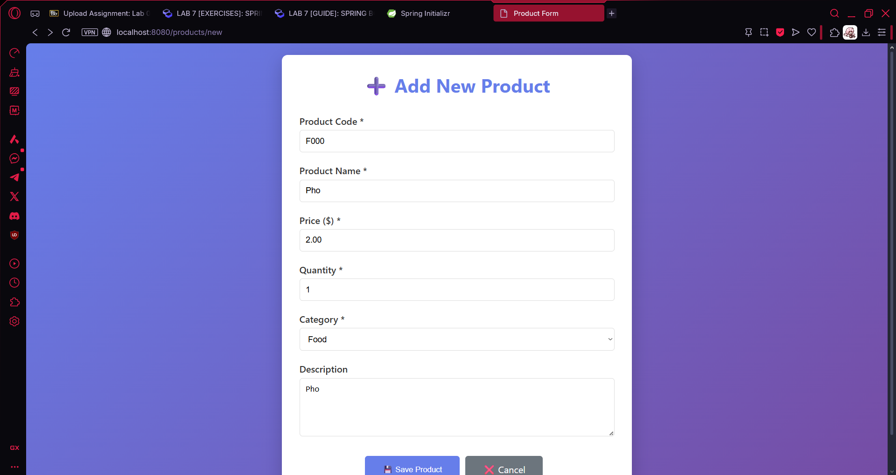
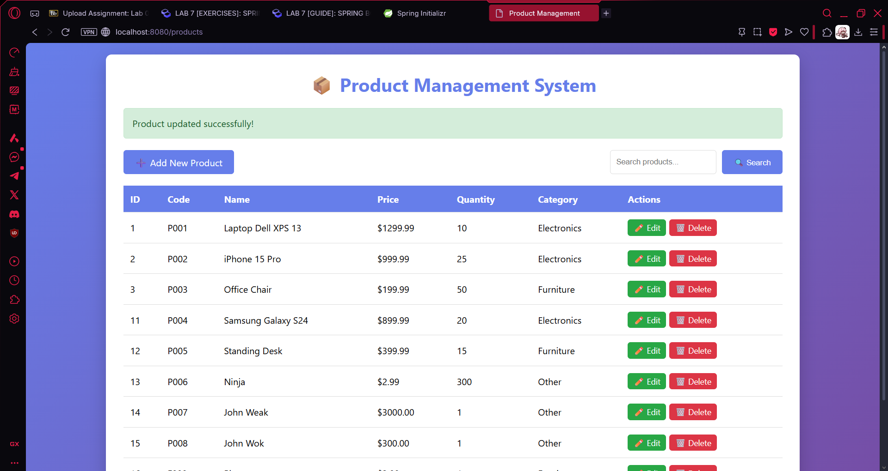
- Edit product:
When user click on edit button, browser will send a GET request to controller. The controller will based on the ID to call service layer for information and then prefill the form before show the form to user. After user edit and click on save product the workflow is the same as save product in add new product.
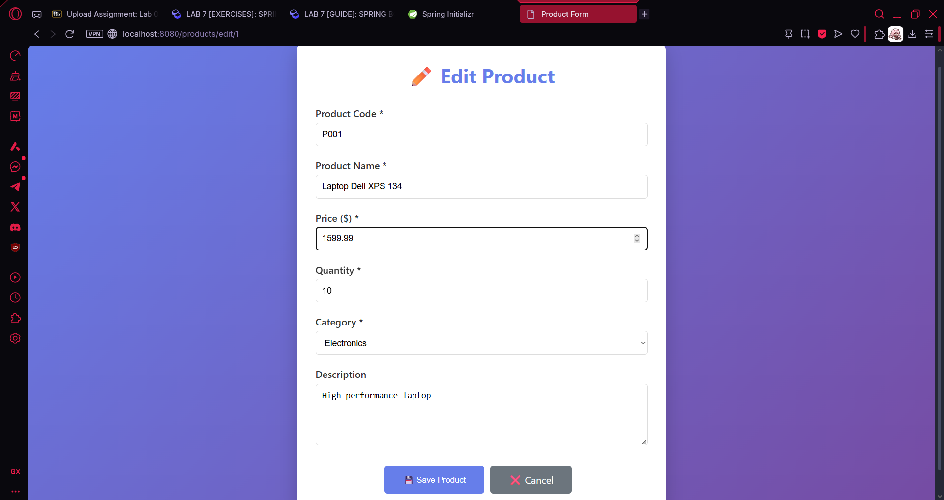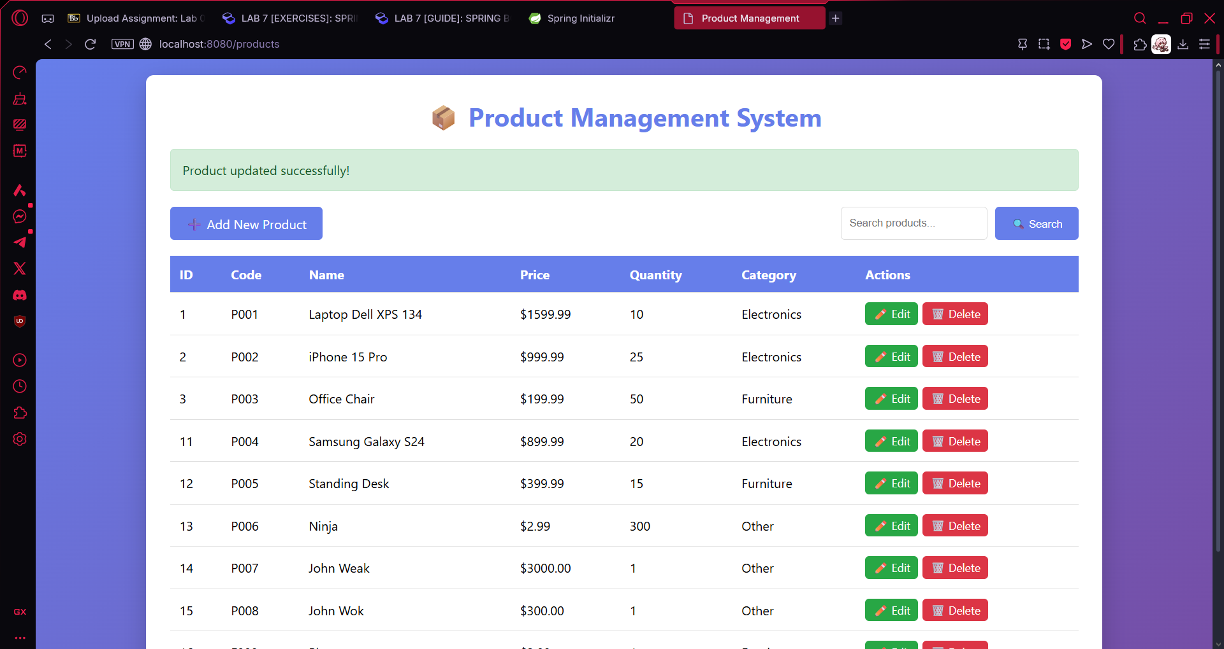

- Delete product:
When user click on delete product button, the javascript confirmation ask confirm to delete product. After user confirm, browser will send a GET request to controller to call deleteProduct function. This function will based on product ID to call service layer deleteById and database will run DELETE query to remove product with corresponding ID out of database and finally redirect back to /products and show success message